Respirable Crystalline Silica Management Procedure

Introduction
This procedure outlines the requirements for minimising exposure or being affected by silica-containing material. The most significant health concern is that a person can be in contact with silica and suffer little to no effect at the time of exposure, but over time develop into a serious health condition or cause death.

Scope
This document covers the PCBU, all workers, contractors and visitors to worksites.
Definitions
Crystalline silica is silicon dioxide. It is a naturally occurring component found in earth soils, rocks, sand, granite and many other minerals resulting in many building materials and products. These include engineered stone for kitchen and bathroom benchtops, in concrete, mortar, bricks, tiles and some plastics.

Silica containing material means any material, which has the potential to contain silica at levels, which may pose a hazard to employees when the material is manipulated to create airborne particles.

Silicosis is a lung disease caused by inhalation of silica dust. Silica dust can cause fluid build-up and scar tissue in the lungs that cuts down the ability for the lungs to fully function. The disease is not curable, but can be prevented through the use of protective systems.

Respirable crystalline silica means quartz, cristobalite, and/or tridymite contained in airborne particles that are determined to be respirable by a sampling device designed to meet the characteristics for respirable-particle-size-selective samplers.

Roles and Responsibilities
Managers are responsible for:
- the identification of hazards and the implementation of any known risk control measures in consultation with workers and/or health and safety representatives
- the completion of risk assessments using form WHSFOR -329B for any risks or hazards that are not controlled to protect health and safety of workers

Workers are responsible for:
- reporting any hazards associated with the working environment, work tasks or activities to their manager/supervisor as soon as becoming aware of them
- participating in the conduct of risk assessments and development of appropriate risk control measures for identified hazards to eliminate or minimise risk
- using control measures as required and any other action taken, which is designed to protect health and safety

Identifying the Hazard of Silica Dust
When workers cut, crush, drill, polish, saw or grind stone or products that contain crystalline silica, dust particles are generated. These dust particles, known as respirable crystalline silica or silica dust, are small enough to lodge deep in the lungs and cause illness or disease including silicosis.

Respirable silica dust is invisible to the naked eye and can hang in the air or for a long time after work has finished. Larger, visible dust particles settle long before invisible dust particles do, meaning workers can breathe in respirable dust even if they cannot see it in the air. Respirable crystalline silica particles are less than 10 microns (µm) in diameter and when breathed in can reach deep into the lungs.

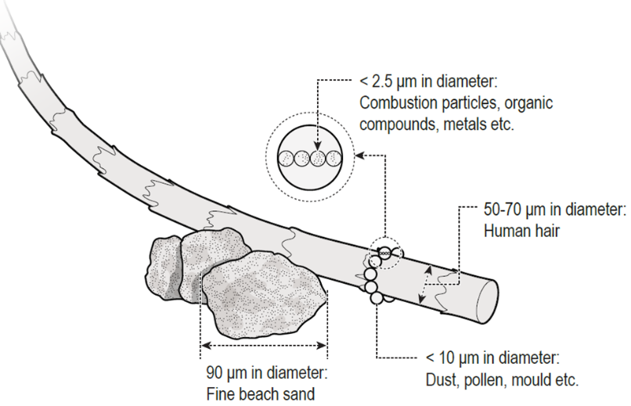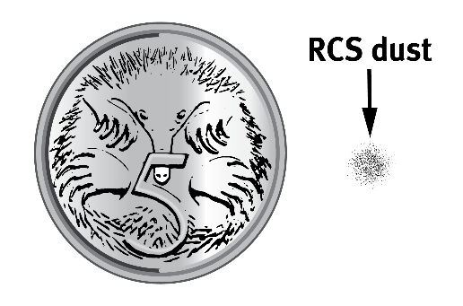

Figure 1: Dust particle sizes

Silica dust can be released when:
- Concrete cutting and using power tools on stone
- Fabricating, installing, maintaining and removing silica engineered containing products such as bench tops
- Cutting, grinding, trimming, removing or blasting silica containing products or from storing or disposing of dusty waste from these processes
- Excavating, earth moving and drilling plant operations
- Clay and stone processing machine operations
- Paving and surfacing
- Mining, quarrying and mineral ore treating processes
- Road construction and tunnelling
- Construction labouring and demolition
- Brick, concrete or stone cutting; especially using dry methods
- abrasive blasting (blasting agent must not contain greater than 1 per cent of crystalline silica)
- Foundry casting
- Angle grinding, jack hammering and chiselling of concrete or masonry
- Hydraulic fracturing of gas and oil wells
- Pottery
- Crushing, loading, hauling and dumping of rock or muck, and
- Clean-up activities such as sweeping or pressurised air blowing of dust.
Engineered stone products can contain up to 97 per cent silica. The high amount of silica means that there is a very high risk of workers developing breathing problems and silicosis if they breathe in dust made from these products. An increase in the number of workers diagnosed with silicosis and progressive massive fibrosis has been linked to working with engineered stone.
Different types of rock and rock products can contain different amounts of silica, for example:
Type | Amount of silica (%)
Granite | 25 to 40
Shale | 22
Natural sandstone | 67
Engineered stone | > 90
Aggregates, mortar and concrete | Various
To manage risks of silica dust, you must first identify whether silica dust is being generated and released into the air at your workplace. Workers are exposed to silica dust whenever it is airborne, and they can breathe it in.
Silica dust is generated in workplace processes such as crushing, cutting, drilling, grinding, sanding, sawing or polishing of natural stone or man-made silica containing products. Silica dust can be generated and found:
- during manufacturing and construction
- when mining or tunnelling
- in waste or sand-based products, and
- in materials brought to your workplace.
Some dust particles can be so small that they are not visible; these are referred to as respirable particles. Respirable silica dust particles are those that are small enough to breathe in and penetrate deep into the lungs causing permanent damage that can lead to
Controlling the Hazard of Silica Dust
Managing risks and worker exposures to silica can be achieved by selecting and implementing measures using the hierarchy of controls’he work health and safety hierarchy of risk control, ranked from the highest level of protection and reliability to the lowest, suggests the following controls:
Control for Respirable Crystalline Silica dust exposure must be put in place if the exposure can’t be eliminated and more than one control will likely be required.
Engineering controls – dust suppression
- Apply water suppression systems to reduce dust generation.

Engineering controls – dust extraction / LEV
- Use local exhaust ventilation (LEV) systems to remove dust at the source
- Ensure LEV is correctly placed and operates at effective flow rates
- Use dust removal systems on tools to reduce dust exposure of mobile workers.

Engineering controls – isolation / containment
- Isolate areas of the workplace where dust is generated by other workers
- Exhaust and filter air from the isolated area.

Administrative controls
- Ensure regular housekeeping to prevent the accumulation of dust
- Restrict time of exposure / use worker rotation.

Personal Protective Equipment
- Provide personal protective equipment (PPE) that is suitable for the nature of the work and the hazard, is comfortable to wear and of a suitable size and fit, is maintained / repaired / replaced when needed, and is used or worn by workers trained in its use and care
- Assess levels of personal exposure among workers performing high risk tasks.

You must provide suitable information, training, instruction and supervision to workers in the use, storage and handling of hazardous chemicals, taking into account the nature of the work, the associated risks and any control measures implemented.

You must also review and revise your control measures, as necessary, to maintain a safe work environment that is without risk to health or safety, so far as is reasonably practicable. This may include both worksite, via an occupational hygienist, and external health monitoring.

If health monitoring is undertaken, records must be kept for 30 years. Health monitoring must be undertaken by a registered medical practitioner, such as thoracic society registered, familiar with the national requirements for silica health monitoring.

Exposure Monitoring
Exposure standard are listed in Safe Work Australia - Workplace exposure standards for airborne contaminants. Effective 1 July 2020, SafeWork SA implemented a nationally agreed reduced workplace exposure limit (or WEL) for respirable crystalline silica to an 8-hour time weighted average of 0.05mg/m3.
[Company] must ensure that no person at the workplace is exposed to a substance or mixture in an airborne concentration that exceeds the exposure standard for the substance or mixture. If there is doubt as to whether the exposure standard is being exceed or the effectiveness of controls are in doubt Respirable Crystalline Silica dust monitoring should be undertaken to determine the level of airborne respirable crystalline Silica is in workplace. The results of air monitoring carried out must be recorded, kept for30 years and readily accessible to persons at the workplace who may be exposed to the substance or mixture.
Health Monitoring
Workers who may be at significant risk of exposure to crystalline silica must be offered regular health monitoring (chest x-rays and lung capacity tests) by their employer.

References

WHS Act, 2012 (SA)
WHS Regulations 2012 (SA)
Safe Work Australia - Workplace exposure standards for airborne contaminants
Code of Practice How to Manage Work Health and Safety Risks 2021
Workplace Health and Safety Queensland - Silica—Identifying and managing crystalline silica dust exposure
Workplace Health and Safety Queensland - Silica – Technical guide to managing exposure in the workplace

Authority

Signature:

Authorised by: [XXX] Title: [XXX]

Date: 25 November 2021

